Много страници, Cambridge:
https://drive.google.com/file/d/0B7vfFUQCQ4fka0xrbmFQY29IMTA/view

Networks of spiking neurons: The third generation of neural network models

http://www.igi.tugraz.at/psfiles/85b.pdf От тук:
Класифицираме neural networks според computational units на три поколения:
- McCulloch Pits, threshold-gates
- Активационни функции? Sigmoid,
- Spiking neural network

http://www.mjrlab.org/wp-content/uploads/2014/05/network_python_tutorial2013.pdf

Опростяваме v до следното:
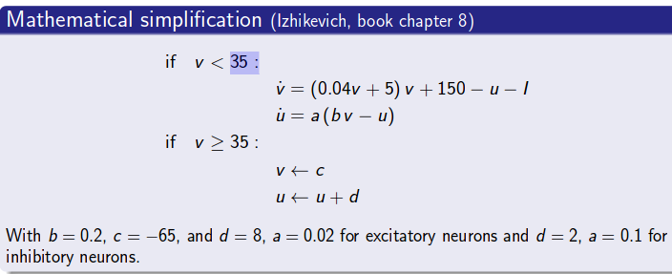
еlectrical pulses – spikes
https://www.elen.ucl.ac.be/Proceedings/esann/esannpdf/es2014-13.pdf

Binary coding - is an all or nothing encoding: a neuron is either active in a
given time interval, that is it fires one or several spikes in that time interval, or it is silent.

https://www.youtube.com/watch?v=AyzOUbkUf3M

